SUPER HERO APPLICATION FORM
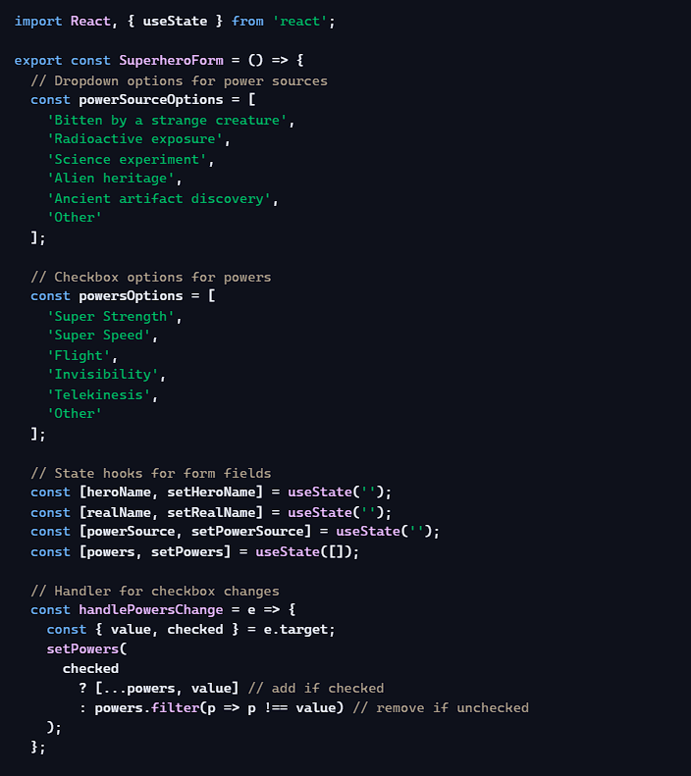

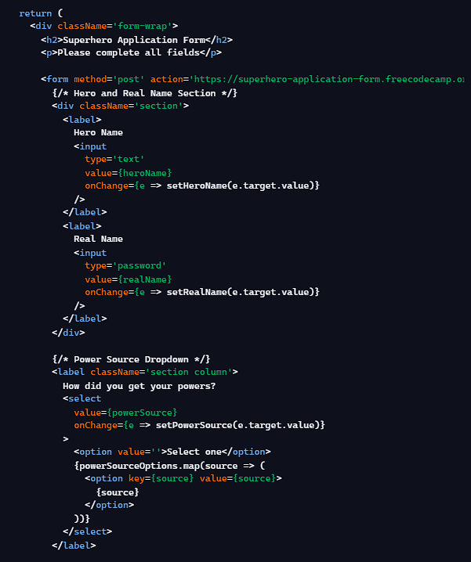

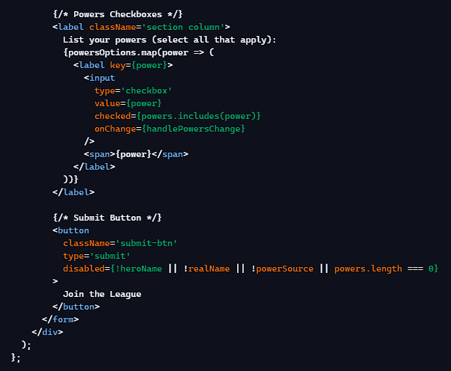
📌 High-Level Purpose
This React component renders a superhero application form. It collects:
- Hero name
- Real name
- Power source (dropdown)
- Powers (checkbox group)
The form only allows submission when all fields are completed and at least one power is selected.
🛠️ Key Concepts Used
- useState → manages form state.
- Controlled inputs → each input’s value is tied to state.
- Event handling → updates state when user types/selects.
- Conditional rendering → disables the submit button until requirements are met.
- Array methods → map, includes, filter used for rendering and updating checkboxes.
